Training resource for creating and editing accessibility metadata MARC tags for library staff

Metadata
Metadata is structured data about data that helps to organize, track, and retrieve data. MARC 21 is the metadata standard for library cataloguing. In a library, the descriptive metadata in bibliographic records allows patrons to find a resource in the online catalogue by searching by author, title, keyword, or subject and to narrow their search by type of material, accessibility feature, or other criteria.

Accessibility metadata
Accessibility metadata helps patrons find resources that meet their specific accessibility needs. Accessibility metadata tells the user which accessibility features a resource has, such as whether a user can change the size of the text while reading an e-Book or if a resource has flashing hazards that could trigger some patrons.
To communicate between publishers, retailers and vendors/distributors, the book industry uses a data format called ONIX for Books Product Information Format (ONIX). ONIX uses controlled vocabularies known as codelists. Codelist 196 is for e-publication accessibility details. The ONIX travels as an XML file within or accompanying a book.
Schema.org creates standard language for web content, including a schema for accessibility metadata. Publishers send ONIX and schema.org accessibility metadata with their digital publications. However, it is not picked up and stored by vendors and distributors or translated into the MARC records they provide to libraries. When this happens, it is possible to look inside the EPUB at the .opf file to get the schema.org metadata and use the Schema.org crosswalk to MARC.
Since the accessibility metadata has already been created by the publisher, opening the .opf file and adding the accessibility metadata to the MARC record should not be necessary. To provide access to the accessibility information publishers are already providing, libraries must advocate to vendors/distributors for all accessibility metadata to be included, displayed, and searchable/filterable.

Accessibility metadata in bibliographic records
The practice of including accessibility metadata in MARC records is evolving. In 2018, MARC21 added two fields for accessibility: 341 Accessibility Content and 532 Accessibility Note. In addition to the MARC fields or tags you usually use when editing or cataloguing, you should also add 341 and 532 tags, where applicable.
The 341 Accessibility Content tag is a machine-readable field that requires controlled vocabulary. The 341 is intended to describe “content that provides alternative sensory modes to perceive the primary content of a resource” (RDA 7.14.1.1). For this reason, it is not used for print braille or large print. The 532 Accessibility Note tag is a free-text note field summary of accessibility features, hazards, and deficiencies of a resource.
Because so few libraries have been using the 341 Accessibility Content tag, it may not be indexed in your library’s Integrated Library System (ILS), meaning that this field is not searchable. Currently, the 341 is not indexed in OCLC. Libraries need to request that OCLC and the companies that own their ILSes make these MARC21 accessibility fields searchable. In the meantime, you should include the appropriate accessibility tags now so retrospective editing will not be necessary later.

341 Accessibility Content (R)
The repeatable 341 tag contains information about textual, visual, auditory, and/or tactile modes of access to the content of a resource. Use controlled language in this field. Currently, terms that can be used in subfield $a is limited to textual, visual, auditory, or tactile.
MARC21 does not provide a vocabulary to be used for $b- $e. Appropriate vocabularies for use with the 341 field can be found on the Library of Congress’s Sources Codes for Vocabularies, Rules, and Schemes webpage under the Accessibility Content Source Codes subgrouping (https://www.loc.gov/standards/sourcelist/accessibility.html). There is currently just one approved vocabulary on this list: Schema.org Accessibility Properties for Discoverability Vocabulary. Cataloguers can use this vocabulary to populate the $b-$e fields, identifying the vocabulary used by including $2sapdv for each occurrence of the 341. Additional information, including definitions of the language and MARC21 examples, can be found in Section 3 From Schema.org.: Accessibility Properties Crosswalk (schema.org, ONIX, MARC21 & UNIMARC).

Indicators
First Indicator
# No information provided
0 - Adaptive features to access primary content
Adaptive features to access primary content of a resource.
1 - Adaptive features to access secondary content
Adaptive features to access secondary content of a resource.
Second indicator
# - Undefined

Subfields
$a Content access mode (NR)
Sensory mode (textual, visual, auditory, or tactile) required to access the content of the resource without using assistive features. If more than one sensory mode is required to access the resource, you must include a 341 tag for each mode of access.
Subfields $b to $e may be repeated in the same $a subfield to record different accessibility features related to the same mode recorded in $a, provided that they are taken from the same source vocabulary, such as the Schema.org Accessibility Properties for Discoverability Vocabulary as in the following example, where the $d repeats:
341 0$a textual $d displayTransformability $d synchronizedAudioText $d structuralNavigation $2 sapdv #
$b Textual assistive features (R)
Textual assistive features and adaptations to access to the content of the resource, such as Display Transformability or high contrast display.
$c Visual assistive features (R)
Visual assistive features and adaptations to access the content of the resource, such as sign Language or a printed transcript.
$d Auditory assistive features (R)
Auditory assistive features and adaptations to access the content of the resource, such as audio description or a supplementary sound recording.
$e Tactile assistive features (R)
Tactile assistive features and adaptations to access the content of the resource, such as braille and tactile graphics.
The $e Tactile subfield may rarely be applicable because accessibility features, including tactile graphics, are not generally included in braille files. When eBRF is released within the next few years, accessibility features will be included and should be noted in this subfield.
$2 Source (NR)
Identification of the source of terms in subfields $b to $e when they are from a controlled list. If your 341 includes language from Schema.org Accessibility Properties for Discoverability Vocabulary, you must consistently include either the code sapdv or w3c. There are currently no other vocabularies approved; however, a project is underway to translate the schema vocabulary into French.
$3 Materials specified (NR)
Optional. Part of the described materials to which the field applies.
$6 Linkage (NR)
For data that links fields when non-Latin script is used. System supplied.
$8 Field link and sequence number (R)
Optional. Identifies linked fields and may also propose a sequence for the linked fields.

341 Examples:
341 0# $a auditory $b captions
341 0# $a auditory $c signLanguage $2 sapdv
341 0# $a auditory $b structuralNavigation $2 sapdv
341 0# $a textual $b structuralNavigation $b displayTransformability $d synchronizedAudioText $2 sapdv
341 0# $a textual $b tagged PDF $b structuralNavigation $2 w3c
341 0# $a textual $b displayTransformability $d synchronizedAudioText $b structuralNavigation $2 w3c
341 0 $a visual $e braille $2 w3c $3 container labels
341 0# $a visual $d audioDescription $2 w3c

532 Accessibility Note (R)
The 532 tag contains textual information describing the accessibility features, hazards, and deficiencies of a resource, including technical details relating to accessibility features. This field may be used to expand on or to qualify data in field 341 (Accessibility Content).
First Indicator - Display constant controller
0 – Accessibility technical details
Devices, equipment, or software required to implement an accessibility feature.
1 – Accessibility features
Provides a description of accessibility features in a resource.
2 – Accessibility deficiencies
Provides a description of content of a resource for which no alternative mode of access has been provided.
8 – No display constant generated
Second Indicator - Undefined
# - Undefined

Subfields
$a – Summary of accessibility
Text describing accessibility features, hazards, and deficiencies, as well as technical details relating to accessibility features.
$6 – Linkage
For data that links fields when non-Latin script is used. System supplied.
$8 Field link and sequence number
Optional. Identifies linked fields and may also propose a sequence for the linked fields.

532 Examples
532 0# $a Daisy 3; Requires Daisy 3 software for access.
532 1# $a Described video
532 1# $a Alternate leaves of print and braille
532 2# $a Menu not navigable

User Perspective
The accessibility metadata fields can be very helpful for the end-user, especially when they are displayed in a way that uses common terms/language. Some ILSes and organizations display their accessibility metadata already.
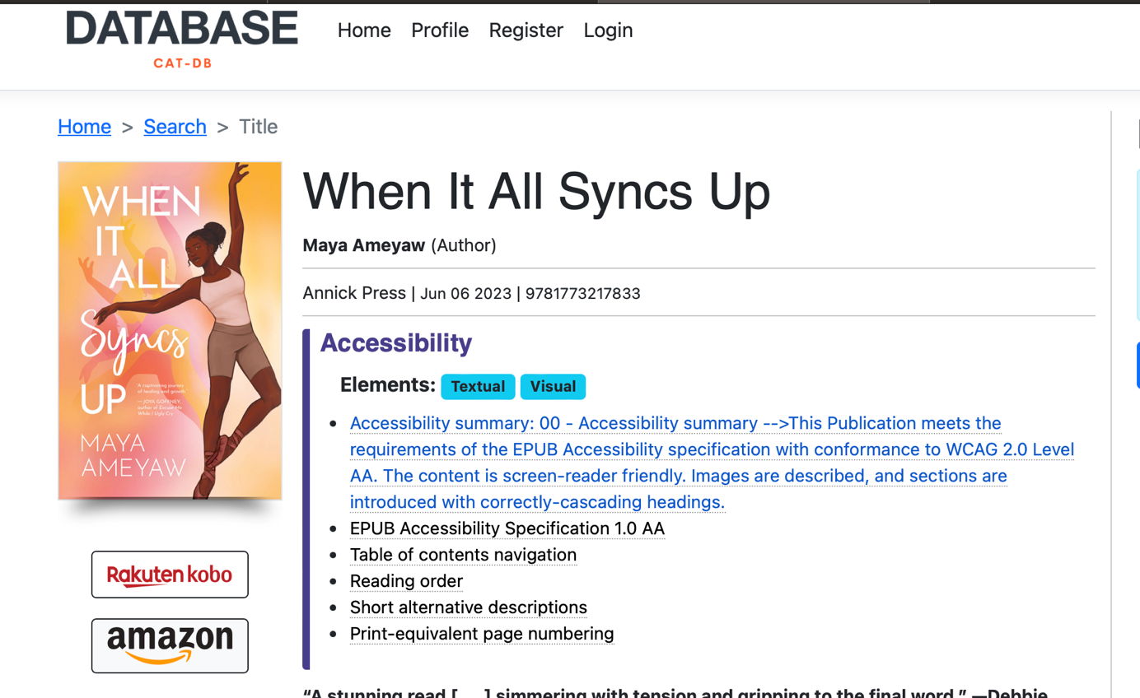
Figure 1: CAT-DB Website
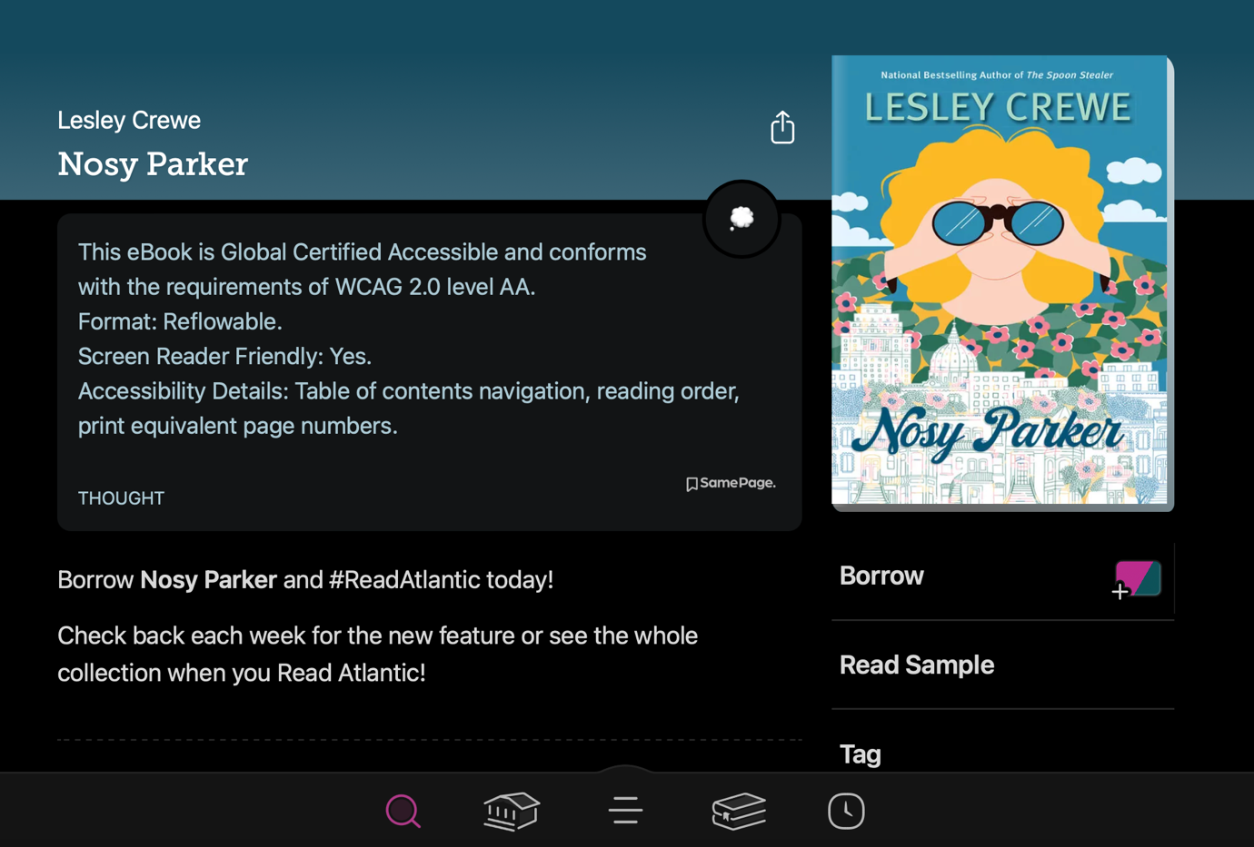
Figure 2: Libby App
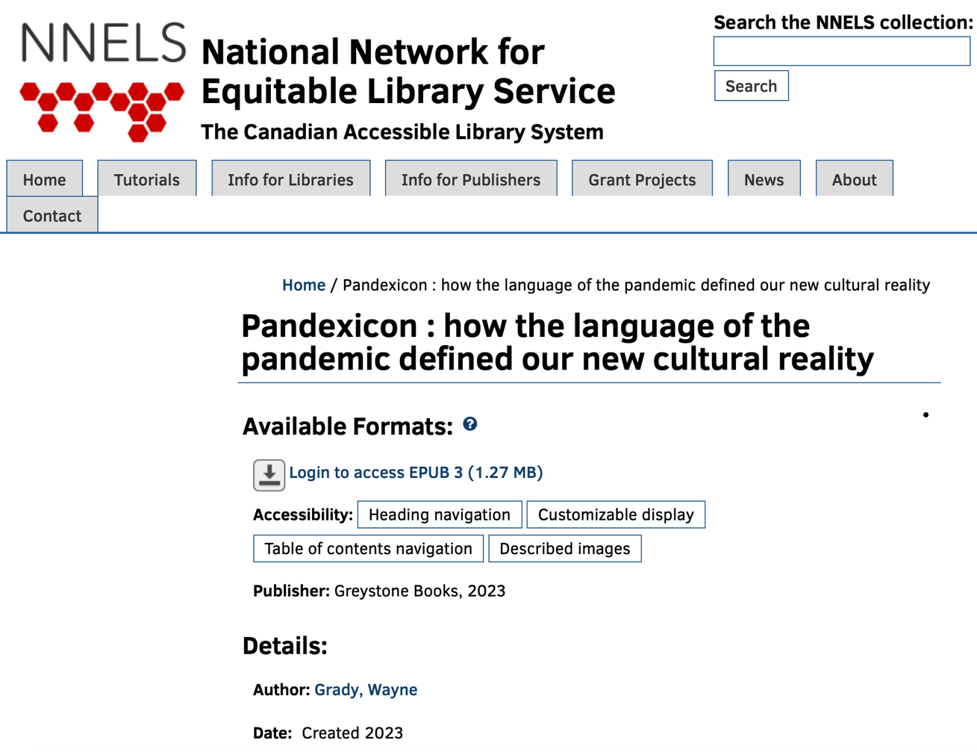
Figure 3: NNELS Repository

Additional resources

Resources about accessibility metadata in publishing
Overview of ONIX for Books Product Information Format
ONIX introduction webinar
w3c User Experience Guide for Displaying Accessibility Metadata
DAISY Consortium webinar on metadata in publishing DAISY Consortium webinar on metadata in publishing

Resources for cataloguing
MARC21 Bibliographic 341 Accessibility Content field MARC21 341 field
MARC21 Bilbiographic 532 Accessibility Note field MARC21 532 field
w3c (2023). Schema.org Accessibility Properties Crosswalk, Final Community Group Report 10 March 2023. Web page. Retrieved from: https://w3c.github.io/a11y-discov-vocab/crosswalk/#schema-onix
w3c (2023). Accessibility Properties Crosswalk (schema.org, ONIX, MARC21 & UNIMARC) 23 March 2023. Web page. Retrieved from: https://w3c.github.io/publ-a11y/drafts/a11y-crosswalk-MARC/index.html

Contributors
The Public Library Accessibility Resource Centre (PLARC) Project Team thanks the following key contributors and writers for their work on this document:
- Chris Carr
- Farrah Little
- Terry Nelson (lead writer)
- Megan Toye

References
Library of Congress, Network Development and MARC Standards Office (2022). Marc 21 Format for Bibliographic Data, 1999 Edition Update No. 1 (October 2000) through Update No. 35 (December 2022). Web page. Retrieved from: https://www.loc.gov/marc/bibliographic/
Library of Congress, MARC 21 MARC Standards (2018). MARC Proposal No. 2018-03, May 25, 2018. Web page. Retrieved from: https://www.loc.gov/marc/mac/2018/2018-03.html
w3c (2023). Schema.org Accessibility Properties Crosswalk, Final Community Group Report 10 March 2023. Web page. Retrieved from: https://w3c.github.io/a11y-discov-vocab/crosswalk/#schema-onix
w3c (2023). Accessibility Properties Crosswalk (schema.org, ONIX, MARC21 & UNIMARC) 23 March 2023. Web page. Retrieved from: https://w3c.github.io/publ-a11y/drafts/a11y-crosswalk-MARC/index.html
w3c (2021). User Experience Guide for Displaying Accessibility Metadata 1.0 Final Community Group Report 27 September 2021. Web page. Retrieved from: https://www.w3.org/2021/09/UX-Guide-metadata-1.0/principles/
Daisy Accessible Publishing Knowledge Base. Schema.org Accessibility Metadata. Website. Retrieved from: http://kb.daisy.org/publishing/docs/metadata/schema.org/index.html

